Common API Security Methods - OAuth 2.0

🔐 What is OAuth 2.0
# Source: AI Source: Provided by: [Data Path: Persons Table -> ID Column: 1, Name_En Column: Motasem Essam] -> From: [ChatGPT] on [1/19/2026]
OAuth 2.0 is a widely used authorization framework that allows applications to access resources on behalf of a user without sharing the user’s password.
👉 Think of OAuth 2.0 as a secure delegation system:
“Allow this app to access my data, but don’t give it my password.”

🔑 Key Concepts
# Source: AI Source: Provided by: [Data Path: Persons Table -> ID Column: 1, Name_En Column: Motasem Essam] -> From: [ChatGPT] on [1/19/2026]
- Access Token → Temporary token used to access API
- Refresh Token → Used to get a new access token
- Scopes → Define what the app is allowed to do (read, write, etc.)
- Authorization Server → Issues tokens
- Resource Server (API Server) → Validates tokens and serves data

🧱 How OAuth 2.0 Works (Simplified Flow)
# Source: AI Source: Provided by: [Data Path: Persons Table -> ID Column: 1, Name_En Column: Motasem Essam] -> From: [ChatGPT] on [1/19/2026]
- User tries to use an app
- App redirects user to Authorization Server (login)
- User logs in and grants permission
- Server returns an Access Token
- App uses token to call the API

🧱 Example
# Source: AI Source: Provided by: [Data Path: Persons Table -> ID Column: 1, Name_En Column: Motasem Essam] -> From: [ChatGPT] on [1/19/2026]
API Request with OAuth Token
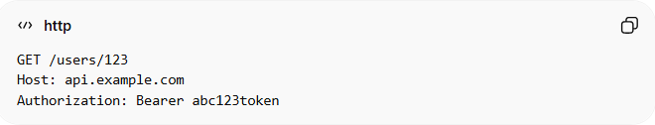
GET /users/123
Host: api.example.com
Authorization: Bearer abc123token
Response
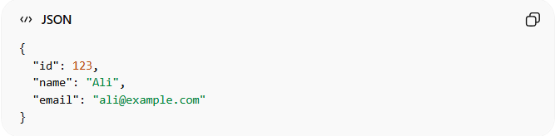
{
"id": 123,
"name": "Ali",
"email": "ali@example.com"
}
✅ Only valid tokens can access the API

🔄 Common OAuth 2.0 Flows
# Source: AI Source: Provided by: [Data Path: Persons Table -> ID Column: 1, Name_En Column: Motasem Essam] -> From: [ChatGPT] on [1/19/2026]
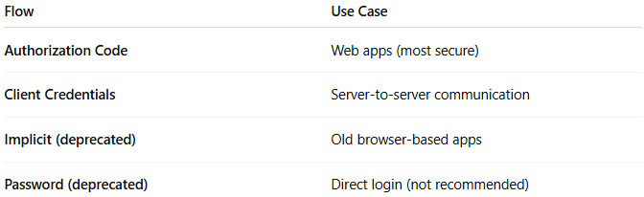
Flow | Use Case
Authorization Code | Web apps (most secure)
Client Credentials | Server-to-server communication
Implicit (deprecated) | Old browser-based apps
Password (deprecated) | Direct login (not recommended)

✅ Advantages
# Source: AI Source: Provided by: [Data Path: Persons Table -> ID Column: 1, Name_En Column: Motasem Essam] -> From: [ChatGPT] on [1/19/2026]
- Very secure (no password sharing)
- Supports fine-grained permissions (scopes)
- Industry standard (used by Google, Facebook, etc.)
- Works well with third-party integrations

❌ Disadvantages
# Source: AI Source: Provided by: [Data Path: Persons Table -> ID Column: 1, Name_En Column: Motasem Essam] -> From: [ChatGPT] on [1/19/2026]
- More complex to implement
- Requires token management
- Needs an authorization server

⚠️ Common Mistakes
# Source: AI Source: Provided by: [Data Path: Persons Table -> ID Column: 1, Name_En Column: Motasem Essam] -> From: [ChatGPT] on [1/19/2026]
- Not validating tokens properly ❌
- Using insecure flows (like password flow) ❌
- Not handling token expiration ❌

🔐 Best Practices
# Source: AI Source: Provided by: [Data Path: Persons Table -> ID Column: 1, Name_En Column: Motasem Essam] -> From: [ChatGPT] on [1/19/2026]
- Use Authorization Code Flow with PKCE
- Always use HTTPS
- Store tokens securely
- Use short-lived access tokens
- Implement proper scope control

🆚 OAuth 2.0 vs API Keys

🔑 Core Difference
# Source: AI Source: Provided by: [Data Path: Persons Table -> ID Column: 1, Name_En Column: Motasem Essam] -> From: [ChatGPT] on [1/19/2026]
- API Key → Who is calling the API? (simple identification)
- OAuth 2.0 → Is this user/app allowed to access this data? (secure authorization)
👉 API Key = ID card
👉 OAuth 2.0 = secure permission system with rules

⚖️ Side-by-Side Comparison
# Source: AI Source: Provided by: [Data Path: Persons Table -> ID Column: 1, Name_En Column: Motasem Essam] -> From: [ChatGPT] on [1/19/2026]
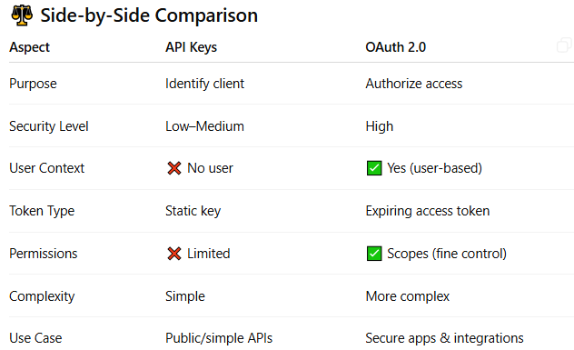
Aspect | API Keys | OAuth 2.0
Purpose | Identify client | Authorize access
Security Level | Low–Medium | High
User Context | ❌ No user | ✅ Yes (user-based)
Token Type | Static key | Expiring access token
Permissions | ❌ Limited | ✅ Scopes (fine control)
Complexity | Simple | More complex
Use Case | Public/simple APIs | Secure apps & integrations

🧱 Example to Make It Clear
# Source: AI Source: Provided by: [Data Path: Persons Table -> ID Column: 1, Name_En Column: Motasem Essam] -> From: [ChatGPT] on [1/19/2026]
🔹 API Key
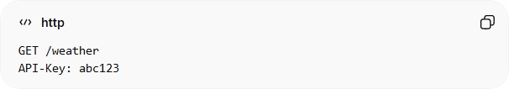
GET /weather
API-Key: abc123
👉 Server says:
“OK, I know this app. Allow access.”
❗ But:
- No idea which user
- No fine control

🔹 OAuth 2.0
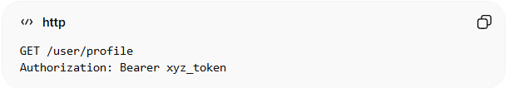
GET /user/profile
Authorization: Bearer xyz_token
👉 Server says:
“This token belongs to Ali, and he has permission to read profile.”
✅ Secure + user-specific

🎯 Real-World Analogy
# Source: AI Source: Provided by: [Data Path: Persons Table -> ID Column: 1, Name_En Column: Motasem Essam] -> From: [ChatGPT] on [1/19/2026]
- API Key → Like entering a building with a general pass
- OAuth 2.0 → Like using a personal badge with permissions
  - You can enter some rooms, not all

⚠️ Why They Feel Similar
# Source: AI Source: Provided by: [Data Path: Persons Table -> ID Column: 1, Name_En Column: Motasem Essam] -> From: [ChatGPT] on [1/19/2026]
Because both:
- Use tokens/keys
- Are sent in headers
- Allow access to APIs
👉 But the depth of security and control is very different

💡 When to Use Each
# Source: AI Source: Provided by: [Data Path: Persons Table -> ID Column: 1, Name_En Column: Motasem Essam] -> From: [ChatGPT] on [1/19/2026]
✅ Use API Keys when:
- API is public or low-risk
- You just need tracking or rate limiting
✅ Use OAuth 2.0 when:
- You need user authentication
- You need permissions (read/write/admin)
- You’re building secure systems or integrations

🚨 Important Insight
# Source: AI Source: Provided by: [Data Path: Persons Table -> ID Column: 1, Name_En Column: Motasem Essam] -> From: [ChatGPT] on [1/19/2026]
API Keys are not enough for sensitive data
OAuth 2.0 is designed for real security and access control

🧾 Summary
# Source: AI Source: Provided by: [Data Path: Persons Table -> ID Column: 1, Name_En Column: Motasem Essam] -> From: [ChatGPT] on [1/19/2026]
- API Keys = simple identification
- OAuth 2.0 = secure authorization system
- They may look similar, but OAuth is much more powerful and secure

💡 Summary
# Source: AI Source: Provided by: [Data Path: Persons Table -> ID Column: 1, Name_En Column: Motasem Essam] -> From: [ChatGPT] on [1/19/2026]
OAuth 2.0 allows secure, token-based access to APIs without exposing user credentials, making it ideal for modern applications and integrations.

